**DAILY ONLINE ACTIVITIES SUMMARY**

|  |  |  |  |  |  |  |  |
| --- | --- | --- | --- | --- | --- | --- | --- |
| **Date:** | **25/06/2020** | | | | **Name:** | **Churashma** | |
| **Sem & Sec** | **4th SEM 'A' Section** | | | | **USN:** | **4AL18CS019** | |
| **Online Test Summary** | | | | | | | |
| **Subject** | | **No test** | | | | | |
| **Max. Marks** | | **-** | | **Score** | | **-** | |
| **Certification Course Summary** | | | | | | | |
| **Course** | **Introduction to R** | | | | | | |
| **Certificate Provider** | | | **greatlearning academy** | **Duration** | | | **3.5 hours** |
| **Coding Challenges** | | | | | | | |
| **Problem statement 1: Write a C Program to reverse the rows in a 2d Array.** | | | | | | | |
| **Status: completed** | | | | | | | |
| **Uploaded the report in Github** | | | | **yes** | | | |
| **If yes Repository name** | | | | **https://github.com/Churashma/Lockdown-coding** | | | |
| **Uploaded the report in slack** | | | | **yes** | | | |

ONLINE TEST DETAILS: No test.

CERTIFICATION COURSE DETAILS: Today I studied about Plots_Categorical. In a mosaic plot, the box sizes are proportional to the frequency count of each variable and studying the relative sizes helps you in two ways. It helps you estimate the relative occurrence of each variable. It helps you estimate the correlation between the variables.

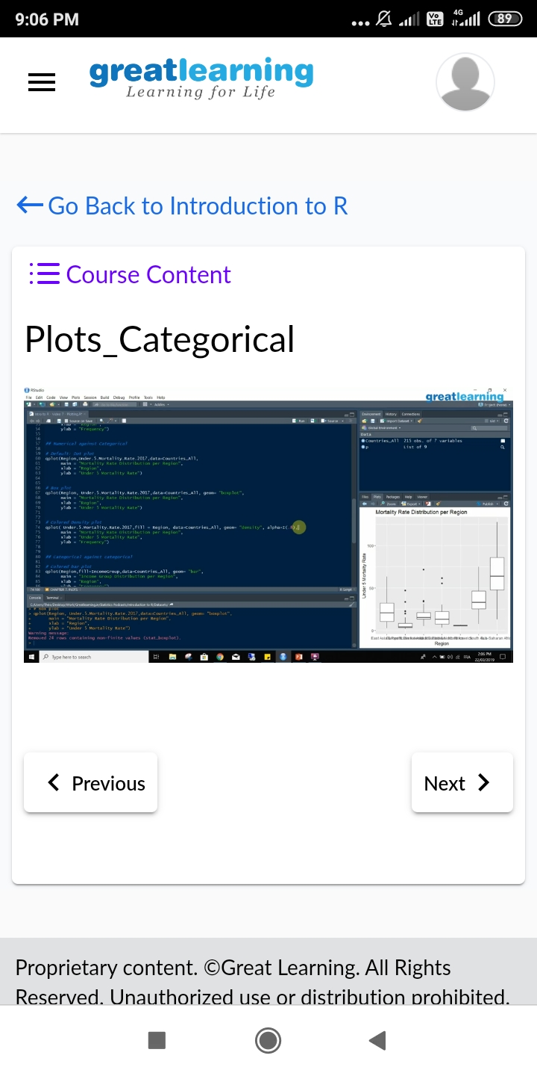

**CODING CHALLENGES DETAILS**:

Problem statement 1: Write a C Program to reverse the rows in a 2d Array.

